[Spring Batch + H2 Database - ConcretePage.com](https://www.concretepage.com/spring-5/spring-batch-h2-database)

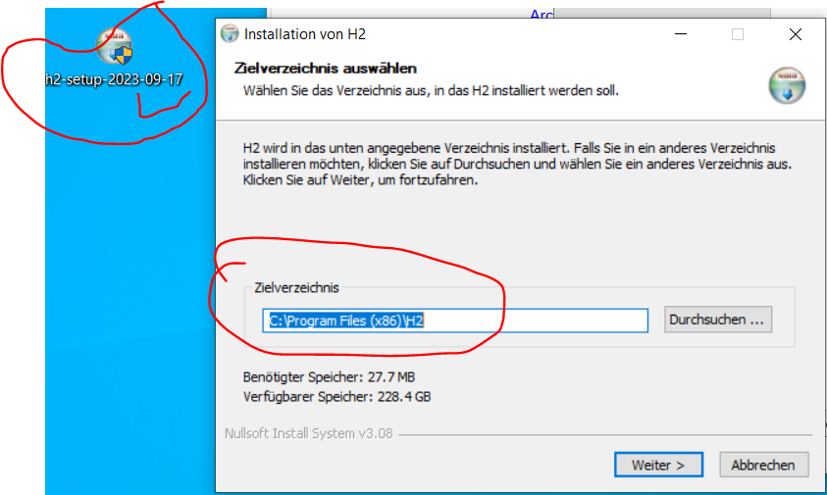

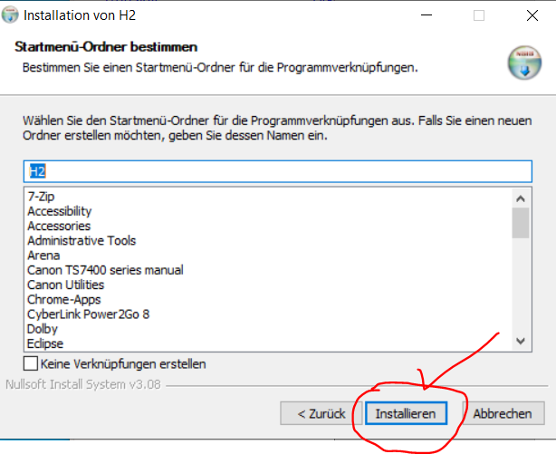

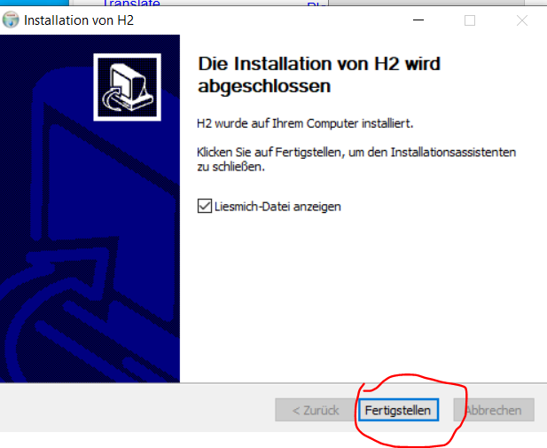

<file:///C:/Program%20Files%20(x86)/H2/docs/html/main.html>

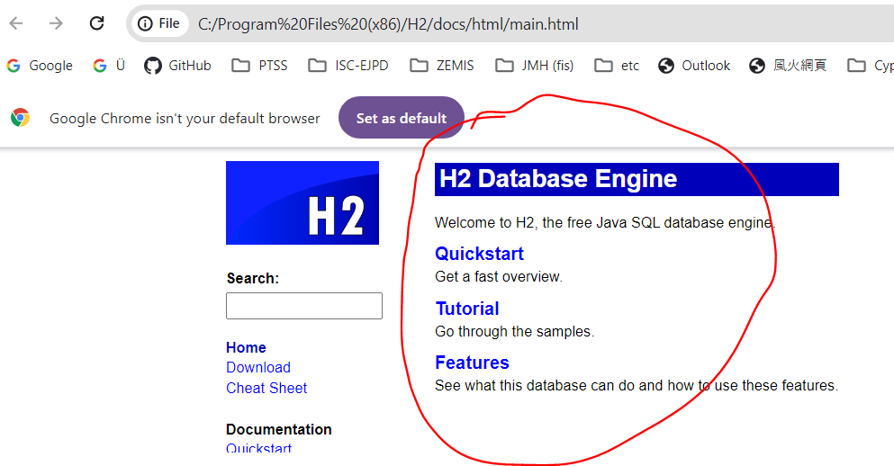

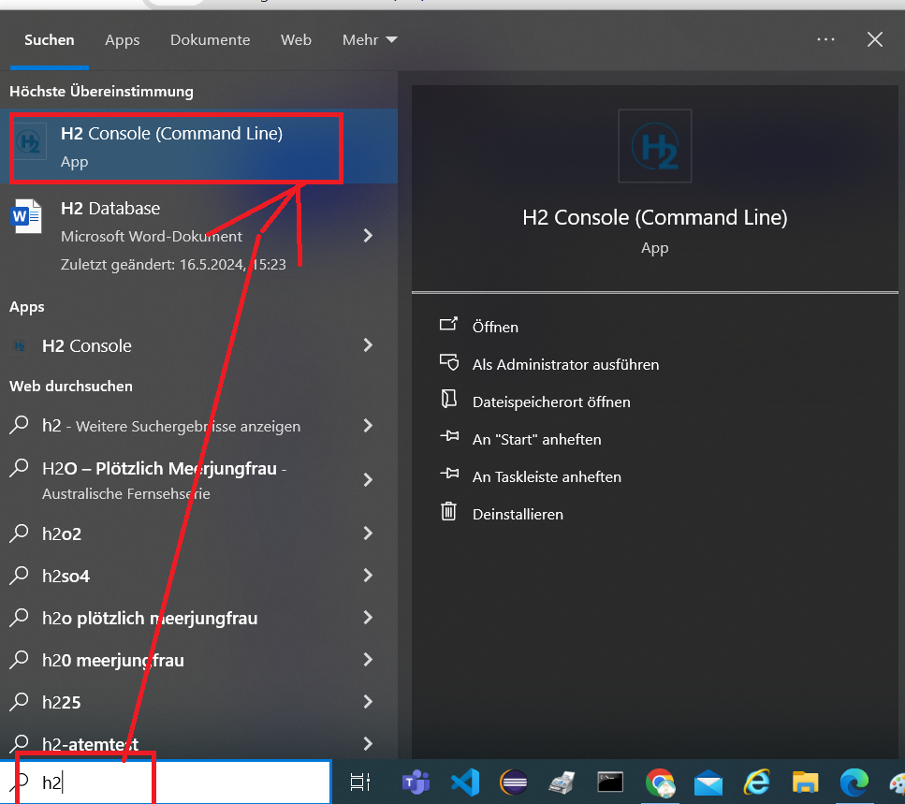

http://192.168.1.160:8082/login.jsp?jsessionid=a340e471e4d2aab0cbe40ff72d4b4a78

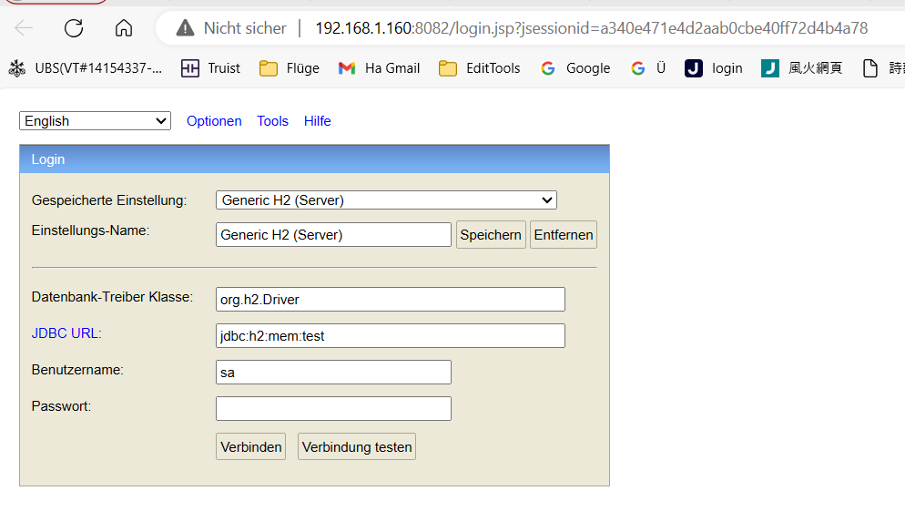

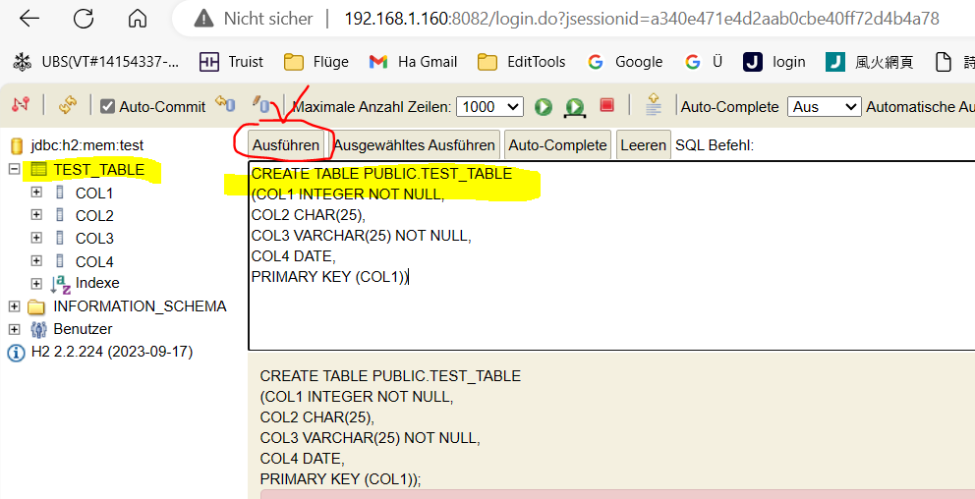

CREATE TABLE PUBLIC.TEST_TABLE  
(COL1 INTEGER NOT NULL,  
COL2 CHAR(25),  
COL3 VARCHAR(25) NOT NULL,  
COL4 DATE,  
PRIMARY KEY (COL1))